Chemistry MOLE DAY Project

Project Due Date: MONDAY - OCTOBER 23, 2017

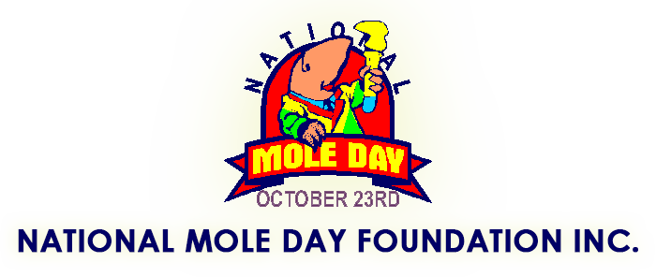

2017 Theme: “The MOLEvengers”
Mole Day. Celebrated annually on October 23 from 6:02 a.m. to 6:02 p.m., Mole Day commemorates Avogadro's Number (6.02 x 10²³), which is a basic measuring unit in chemistry. Mole Day was created as a way to foster interest in chemistry. Schools throughout the United States and around the world celebrate Mole Day with various activities related to chemistry and/or moles.
For a given molecule, one mole is a mass (in grams) whose number is equal to the molar mass of the molecule. For example, the water molecule has a molar mass of 18, therefore one mole of water weighs 18 grams. Similarly, a mole of neon has a molar mass of approximately 20.2 grams. In general, one mole of any substance contains Avogadro's Number of molecules or atoms of that substance. This relationship was first discovered by Amadeo Avogadro (1776-1858) and he received credit for this after his death.
You can do plenty of things to qualify for an Extra Credit Project Grade. All projects MUST INCLUDE a combination of Avogadro’s Number (6.022 x 10 ²³ ), the mole animal, and one or more MOLEvenger(s). After you look over the following list of “suggestions” for possible Mole Day Projects, I have a hunch that you’ll come up with even better ideas!
- Research Amadeo Avogadro and include when and where he lived. Create the front page for a newspaper of that day and locale (research that, too, for an actual newspaper in his home country). Include an article detailing his accomplishments and other articles covering issues and information (political, social, etc.) of his era and region. (Avogadro was very involved in the politics of his day.) Remember YOU MUST incorporate or reference the mole animal, Avogadro’s number, and one or more MOLEvenger(s).
- Dress as a “mole,” any kind of mole (the animal, the spy, the skin, the skin condition, the Mexican sauce, etc.). Remember YOU MUST incorporate or reference the mole animal, Avogadro’s number, and one or more MOLEvenger(s).
- Make mole buttons. (Button-making kits are available at craft stores.) Require students who choose this activity to make several of the same design, then exchange designs with other students and, of course, give 1 to the teacher. All of you wear them throughout Mole Day. Remember YOU MUST incorporate or reference the mole animal, Avogadro’s number, and one or more MOLEvenger(s).
- Create a poster, banner, etc., illustrating something familiar with the actual size of the number 6.02 × 10²³. Remember YOU MUST incorporate or reference the mole animal, Avogadro’s number, and one or more MOLEvenger(s)- (Example: see Modern Chem. page #83, ^{3rd} paragraph: “To get a sense of how large…”).
- Concoct edible goodies such as Avogadro dip and bake mole (not using the animal as an ingredient, yuck!) cakes, cookies, cupcakes, brownies, etc. Some clever cook might create a recipe, using 1 mole of flour, sugar, chocolate, etc. Remember YOU MUST incorporate or reference the mole animal, Avogadro’s number, and one or more MOLEvenger(s).
- Design a mole T-shirt. There are many possibilities here from the animal to the sauce. Remember YOU MUST incorporate or reference the mole animal, Avogadro’s number, and one or more MOLEvenger(s).
- Make posters and hang them in hallways around school inviting everyone to celebrate. (Students who do this project need to turn it in early.) Remember YOU MUST incorporate or reference the mole animal, Avogadro’s number, and one or more MOLEvenger(s).
- Build a mole home, as for the animal, using a mole (22.4 L of gas)-sized container. Remember YOU MUST incorporate or reference the mole animal, Avogadro’s number, and one or more MOLEvenger(s).
- Calculate in grams a mole of several substances and display them for comparison. Remember YOU MUST incorporate or reference the mole animal, Avogadro’s number, and one or more MOLEvenger(s).
- Compose poems, stories, or songs, and don’t forget the mole jokes. There is a lot of mole humor online; take a look. Remember YOU MUST incorporate or reference the mole animal, Avogadro’s number, and one or more MOLEvenger(s).
- Draw and illustrate a cartoon of a mole. Remember YOU MUST incorporate or reference the mole animal, Avogadro’s number, and one or more MOLEvenger(s).
- Create a mole hand puppet or stuffed animal and make it your companion for the day. Remember YOU MUST incorporate or reference the mole animal, Avogadro’s number, and one or more MOLEvenger(s).
- Design a 14” x 22” colored poster illustrating a creative relationship between the mole animal, Avogadro’s number, and one or more MOLEvenger(s).
***NOTE: All Mole Day Projects MUST include some reference or representation of a relationship between MOLEvengers, Avogadro’s number, and the animal.
SCORING RUBRIC: Lab Report/Project Grade out of 12 points total (4 points maximum for incorporating and/or referencing each of the following three categories: 1.) MOLEvengers, 2.) the mole animal, and 3.) Avogadro’s Number. Individual or two member team project submissions ONLY!

Chemistry MOLE DAY Project

Project Due Date: MONDAY - OCTOBER 23, 2017 (No Extensions!)

